Cheat Sheet

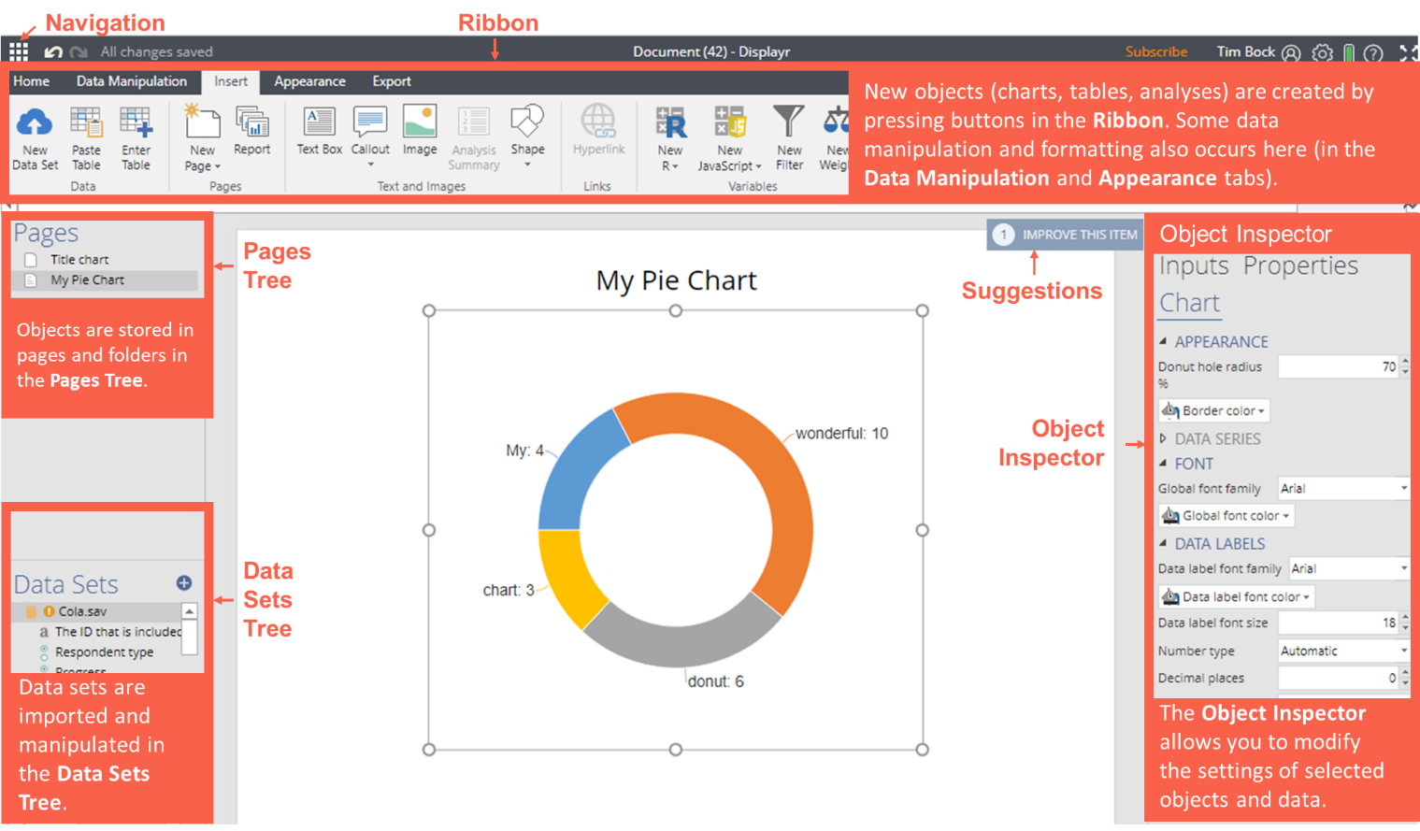

Key Concepts
- Add raw data sets to the Data Sets Tree (bottom-left), or, add pre-calculated data to existing visualizations (see Workflow).
- The Data Sets Tree contains sets of one or more variables (variable sets); the structure of a variable set determines how it is analyzed.
- Create tables and other analyses using options in Ribbon > Insert or by dragging variables sets from the Data Sets Tree (bottom-left) onto the page.
- Press Ribbon > Home > New Page to create new pages. Drag and drop pages to organize documents. Folders are created by dragging pages onto other pages.
- Pages and other objects can be hidden from exports by selecting them and clicking Ribbon > Appearance > Hide.
- Arbitrary calculations are performed using Ribbon > Insert > R Outputs (see Extracting results from tables using R Outputs).
- Modify objects by clicking on them and either
  - Directly manipulating them (e.g., moving or resizing them).
  - Modifying more commonly used options in the Ribbon (top of the screen).
  - Modifying options in the Object Inspector (right-side of the screen).
- Trace any calculation back to the original data by hovering over the data input and pressing the that appears in the preview window.
- Use Ribbon > Export to publish the document as a web page, PDF, PowerPoint, or Excel file.

Workflow

- Plan your dashboard | Create a detailed plan for the dashboard (e.g., by prototyping slides in PowerPoint). It should show all the pages you want to create and the layout on each of those pages.
- Design and layout | (Optional) Get a graphic artist to create a color palette, style guide, and images as PNGs and JPEGs  Dashboard Design: Working with a Graphic Designer  (Optional) Perform more advanced customizations using via the CSS  Customizing Logos, Icons, CSS, HTML Headers, and Language in Displayr
- Create a document | Log in to Displayr and click + Add New (If using in conjunction with Q, see Using Q Projects in Displayr)  Add and modify text, shapes and images: Ribbon > Insert > Text and images and Appearance  Create folders by dragging pages on top of other pages
- Hook up visualizations to data: there are four flows | Flow A: Type in data  - Ribbon > Insert > Visualization  - Object Inspector > Inputs > DATA SOURCE > Paste or type data |  |  | Flow B: Insert Pre-Calculated Tables  - Ribbon > Insert > Paste Table  - Extract results from tables using R Outputs  - Ribbon > Insert > Visualization  - Object Inspector > Inputs > DATA SOURCE: Outputs in ‘Pages’ |  | Flow C: Analyze imported data sets (raw data)  - + Add a data set  - Create a table (Tables)  - Extract results from tables using R Outputs  - Ribbon > Insert > Visualization  - Object Inspector > Inputs > DATA SOURCE: Outputs in ‘Pages’ or Variables in ‘Data’ |  |  | Flow D: Live updating  Either Flow B or Flow C, except with Updating with Revised Data
- Duplicate | Create something, and press Home > Duplicate, and modify the input data. You can apply this to everything from a text box through to a whole report.
- Export | Ribbon > Export > Excel, PDF, Web Page  When exporting to a web page, the resulting dashboard is seen by the viewer in view mode.  Prevent items from being exported by selecting them and pressing Ribbon > Appearance > Hide
- Filters for clients | Select the variables(s) in the Data Tree and click Insert > Utilities > Filtering > Create Filters from Selected Data
- Create navigation | Set hyperlinks to text, shapes, images, and charts: Insert > Hyperlink  Hide the navigation bar (pages) from view mode by clicking the bottom of Export > Web Page and checking Hide Navigation Pane
- User management | Press (top left of Displayr) > Company Settings, press Expand (only if this option is available at the bottom of the page), and + New User.  To allocate a license to a user, go to Licenses tab and press Professional user > Add (to buy a new license) or Professional user > Assign (to assign an existing license to that user).  To create groups of users (with access to different documents), press + New Group  To assign user access to individual document, go to the Documents page, hover over your document and click Settings, then go to Properties and modify which use groups have access to the document (Authorized for…) and individual pages in the document (Set tab-based access to document)
- Updating with revised data | A. Manual updating of a data set  Click on the data set in the Data Sets Tree, and press Update in the Object Inspector | B. Manual updating of a table/  visual-ization  Click on the table or visualize-ation and click Object Inspector > Inputs > DATA SOURCE > Edit Data | C. Automatic updating via SQL  Data Sets Tree > + Add a data set > SQL > specify Automatic-ally refresh every |  | D. Automatic updating via URL  Data Sets Tree > + Add a data set > URL > specify Automatic-ally refresh every |  | E. Automatic updating of R Outputs  Ribbon > Insert > R Output | F. Automatic updating of R Outputs  Data Sets Tree > + Add a data set > R |  | G. API  If you have program-ing skills, you can write code to update using the API
flipTime::UpdateEvery
Automatically Updating R Outputs, R Variables, and R Data Sets

Creating Outputs

Tables  Note that one of the main ways of modifying a table is to change the data in the table, and when this is done all other tables using the same data will also change (see Manipulating tables) | Summary tables | Drag dragging from the Data Sets Tree onto the page
 | Crosstabs | Create crosstabs by dragging a variable set from the Data Sets Tree and releasing it on the Columns slot of an existing table
 | Duplicate a table | Ribbon > Home > Duplicate
 | Changing the data | Object Inspector > Inputs > DATA
 | View additional statistics | Object Inspector > Inputs > STATISTICS
 | Multiway table (layers) | Ribbon > Insert > More > Tables > Multiway Table
 | Create lots of tables | Ribbon > Insert > Report

Manipulating tables  If a table is created by dragging variables sets from the Data Sets Tree, the categories of the table can be manipulated by dragging and dropping, and the changes apply to all other analyses based on the variable sets. | Merging categories | Click on the row or column name on a table and drag , or, select all the categories to be merged and press Ribbon > Data Manipulation > Merge
 | Creating NETs | Select the categories and press the Ribbon > Data Manipulation > Create NET
 | Sorting/Re-ordering categories | Click on the row or column name on a table and drag , or, Ribbon > Data Manipulation > Sort
 | Removing a category and/or rebasing | Click on the variable set in the Data Sets Tree and press Object Inspector > Properties > DATA VALUES > Missing values
 | Switch between % and averages as main statistics on a table | Click on the variable set in the Data Sets Tree and change the Object Inspector > Properties > INPUTS > Structure (see Variable Set Structures)

Weights and filters  Weights and filters can be applied to the entire project or to selected tables and plots.  Where visualizations and R Outputs are created from tables, weights need to be applied to the source table. | Use existing variables as filters/weights | Select the variable in the Data Sets Tree and press Object Inspector > Properties > GENERAL > Usable as a filter or Usable as a weight
 | Create new weights or filters manually | Ribbon > Insert > New Filter or New Weight
 | Apply weights and filters | Weights and filters can be created and applied from the Inputs tab of the Object Inspector when a page, table, or other output is selected.
 | Create complicated weights and filters | Ribbon > Insert > New R/JavaScript (Variable) > Numeric and press Object Inspector > Properties > GENERAL > Usable as a filter
 | Apply filters and weights to an object | Click on the object: Object Inspector > Inputs > WEIGHTS/FILTERS
 | Show sample size on page | Ribbon > Insert > More (Analysis) > Data > Sample Size Description
 | Linking filters to controls | How to Connect Filters to a Combo Box (Control)  Combo Boxes (Controls) With Dynamic Lists in Displayr
 | Weights and filters in R Code | The filter variable is called QFilter and the weights can be used as either QPopulationWeight, which contains the raw weight, or QCalibratedWeight, which sums to the effect sample size computed using Kish’s approximation

Extracting results from tables using R Outputs  R Outputs are general-purpose outputs, which can contain text, tables, and visualizations. Code is used to determine their contents.  A common use case for R Outputs is to contain results from a larger table. | Creating an R Output | Ribbon > Insert > R Output, enter code in R CODE, and click Automatic
 | Finding the name of a table | Click on the table: Object Inspector > Properties > General > Name
 | Extracting a value from a one-dimensional table | For example, to extract the result for Males from a table containing gender data: table.Gender["Male"] or, if the males are in the second cell of the table: table.Gender[2]
 | Extracting a value from a two-dimensional table | For example, to extract the result for Males aged 35 to 44: table.Gender.by.Age["Male", "35 to 44"]
 | Extracting ranges of data from a table | For example, to extract the result for Males for columns 2 through 4: table.Gender.by.Age["Male", 2:4]

Variables  Tables, visualizations, and analyses take variables and variable sets as inputs. A variable set is a set of one or more variables.  Displayr automatically groups variables into variable sets when data sets are imported. | Split a variable set into individual variables | Click on the variable set in the Data Sets Tree and press Ribbon > Data Manipulation > Split (Variables)
 | Combine individual variables into a variable set | Click on the variables in the Data Sets Tree and press Ribbon > Data Manipulation > Combine (Variables)
 | Change the structure of a variable set | Click on the variable set in the Data Sets Tree and press Object Inspector > Properties > INPUTS > Structure (see Variable Set Structures)
 | Recode the values of a variable set (including missing values) | Click on the variable and review Object Inspector > Properties > VALUES > Labels, Values, Missing Values
 | Create a new variable | Ribbon > Insert > New R or New JavaScript
 | Recode into a different variable | Select the original variable and press Ribbon > Home > Duplicate and then see Recode the values of a variable set
 | Banding/categorizing a numeric variable | Ribbon > Insert > New R (Variable) > Numeric Variable with R CODE of cut(VARIABLE.NAME, 2) to create two categories, then set Object Inspector > Properties INPUTS > Structure to Nominal

Troubleshooting

- When you are stuck, click on whatever you are trying to modify and:
    - Click the Suggestions which pop up in the top right corner of the screen
    - Look around the Ribbon
    - Look around the Object Inspector: it has multiple tabs and groups to be expanded
- Read our wiki and our blog
- If writing R code, hover your mouse over code to see additional documentation, use google, and read the warnings and errors that appear above the Object Inspector
- Click on any errors and warnings in the Pages Tree and the Data Set Tree
- Contact us: support@displayr.com

What to do when the data in a table looks wrong | Check the sample size of a table | When you create a table, the sample size is shown at the bottom of the page.  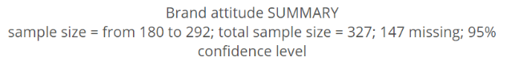
 | Check count and sample size | Object Inspector > Inputs > STATISTICS > Cells > Count or Sample Size
 | Check the variable set structure | Click on the input variables in the Data Sets Tree, and review Object Inspector > Properties > INPUTS > Structure (see Variable Set Structures)
 | Check that the appropriate Filter and Weight have been applied | Select the output, then check Object Inspector > Inputs > FILTERS & WEIGHT
 | Review the value attributes of the input variable(s) | Click on the variable and review the options in Object Inspector > Properties > DATA VALUES
 | View the raw data | See Viewing raw data
 | Review how the input variables have been constructed | Click on the variable and review its R CODE or JAVASCRIPT CODE in the Object Inspector > Properties
 | If using Q: In Q check that the correct Rules are applied and, try and remove the rules | 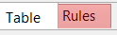  If a rule has been applied, a pink Rules tab will appear at the bottom of the table. Control when applied using the Apply dropdowns
 | If using Q: In Q, check if empty rows/columns are hidden (Q users only; in Q) | Check to see if is depressed (this hides empty rows and columns)

What to do when a visualization looks wrong | Check the source data | Click on the visualization, hover over the data inputs (Object Inspector > Inputs > DATA SOURCE), and click the to go to the input or inputs.  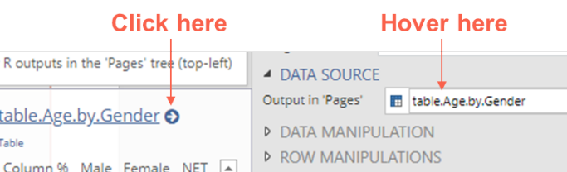  See What to do when the data in a table looks wrong
 | View the data table | Set Object Inspector > Inputs > OUTPUT > Chart type to Table
 | Modify the data manipulation settings | If the data table looks wrong, but the inputs look correct, check the settings in Object Inspector > Inputs > DATA MANIPULATION, ROW MANIPULATIONS, and COLUMN MANIPULATIONS

Viewing raw data | Viewing the raw data for a variable set | Drag the variable onto the page, and in the Object Inspector set Inputs > DATA > Columns to RAW DATA
 | Seeing raw data for lots of variables in Excel | - Select Ribbon > Insert > More > Tables > Raw Data  - Select the desired variables in Object Inspector > Inputs > Variables  - Click Automatic.  - Select Ribbon > Export > Excel  - Click Export and open in Excel
 | Viewing the raw data for multiple variables | Insert > More (Analysis) > Tables > Raw Data and select the Variables and check Automatic

Variable Set Structures

When you create a table in Displayr from data stored in a data set, the way the table appears is determined by the structure of the variable set (group of variables). Each variable set is represented as a folder in the Data Sets Tree. Each structure is represented by an icon. Structures are set automatically when importing data and can be modified in the Object Inspector.
Structure | Description | Example
Text | A single variable containing text (or, numeric data that is interpreted as text) | What is your name? _____________
Nominal | A single variable that contains unordered, mutually exclusive, and exhaustive categories (i.e., has a nominal measurement scale) | Gender categories: Male, Female, Unknown
Ordinal | A single variable that contains ordered, mutually exclusive, and exhaustive categories (i.e., has an ordinal measurement scale). | Age categories: Under 18, 18 to 24, 25 to 29, 29 to 54, 54 or more
Numeric | A numeric variable (i.e., interval or ratio scale). | The amount of money in a bank account.
Date /Time | A numeric variable where the values represent times and/or dates. It contains the number of milliseconds since 1/1/1970. | What is your date of birth?  ____ / ____ / 19____
Text – Multi | A set of related text variables. | First Name, Last Name, and Street Address
Binary – Multi | A set of related nominal variables, where each value only takes two non-missing values (perhaps after merging categories). | Which of the following have you bought in the past week?  Coke Pepsi Fanta
Nominal – Multi | Multiple related nominal variables. | Which meal did you eat most recently at…  Breakfast Lunch Dinner  McDonald’s  Burger King  Wendy’s
Ordinal – Multi | A set of related ordinal variables (The icon is the same as for Nominal – Multi.) | Please rate your satisfaction with the following airlines:  Low Med High  United  British Airways  Qantas
Number – Multi | A set of related numeric variables measured on the same scale. | Balance of Savings Account, Balance of Credit Card, Balance of Home Loan
Binary Multi – Grid | This is a generalization of a Binary – Multi, where the variables can be ordered in two dimensions. | Which of these brands are cool?  Coke Pepsi Fanta  Which of these brands are young?  Coke Pepsi Fanta  Which of these brands are sexy?  Coke Pepsi Fanta
Number – Grid | This is a generalization of a Number – Multi, where the variables can be ordered in two dimensions. | In the past month, how many economy flights did you take on...  Qantas ___ United ___ Delta ___  …and how many business class flights did you take on...  Qantas ___ United ___ Delta ___
Ranking | A set of related numeric variables that represent a ranking, where the highest number is most preferred, and ties are permitted. | Rank the following brands according to how much you like them...  Coke ____ Pepsi ____ Fanta ____
Binary – Multi  (Compact) | The same underlying data as Binary - Multi, except that is stored as a Nominal – Multi and the unique values correspond to underlying binary variables. For example, in data storing people’s car model ownership, rather than having a binary variable for each model of car, instead the first variable represents peoples first care, the second variable is for their second car, etc. This format should only be used to represent data where it provides massive data storage gains, as it is generally difficult to manipulate and cannot accommodate the notion of missing data well.
Experiment  X | This structure is used to represent the various types of experiments, from randomized experiments (''Fully randomized experiments'' through to ''Conjoint Analysis'' and ''Choice Modeling'') | Which of these would you buy?  Coke $2.00 Can Pepsi $4.20 Bottle Fanta $3.20 Flask

